**Ideation Phase**

**Define the Problem Statements**

|  |  |
| --- | --- |
| Date | 19 September 2022 |
| Team ID | PNT2022TMID32983 |
| Project Name | Smart Solution for Railways |
| Maximum Marks | 2 Marks |

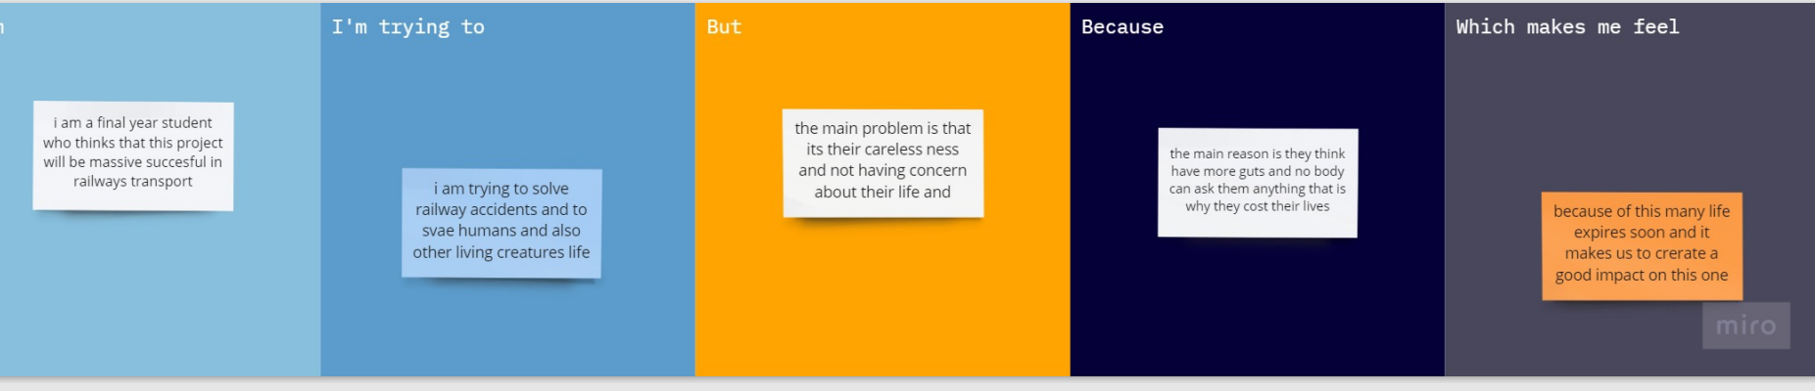

|  |  |  |  |  |  |
| --- | --- | --- | --- | --- | --- |
| I am | | | I am a final year student who thinks that this project will be massive success | | |
| Im trying to | | | I ma trying to solve railway accidents through iot proposed solutions by using modern technology | | |
| but | | | The main problem is their careless ness and not having serious concern about their life | | |
| because | | | The main concern is that they think that nobody can ask them having they think they will be a hero in others point of view which cost their life | | |
| Which makes me feel | | | Very sad about it and have to save their life through the modern technology | | |
| **Problem Statement (PS)** | **I am (Customer)** | **I’m trying to** | **But** | **Because** | **Which makes me feel** |
| **Ps1** | I am a final year student who thinks that this project will be massive success | I ma trying to solve railway accidents through iot proposed solutions by using modern technology | The main problem is their careless ness and not having serious concern about their life | The main concern is that they think that nobody can ask them having they think they will be a hero in others point of view which cost their life | Very sad about it and have to save their life through the modern technology |
| **Ps2** | I am trying to solve the rate of death through the technical method | I am trying to solve railway accidents through iot proposed solutions. | There is no system to ask questions to them who are travelling in the safe less manner | The main concern is that they think that nobody can ask them having they think they will be a hero in others point of view which cost their life | To stop- these things by using modern technology and save their lives |